**Agglomerative cluster DRAFT**

**Group Members:**

**Ngu Quoc Phong 17110060**

**Tran Minh Quang 17110067**

**1. What is clustering in machine learning?**

Intuitively, clustering is the task of grouping a set of objects such that similar objects end up in the same group and dissimilar objects are separated into different groups.

Clustering is an unsupervised learning problem, in which we wish to partition a set of points into “meaningful” subsets.

**2. Types of clustering algorithm?**

K-means Algorithm.

Fuzzy C-means (FCM) Algorithm.

Expectation-Maximisation (EM) Algorithm.

Hierarchical Clustering Algorithms.

**3. What is Agglomerative Clustering?**

Also known as bottom-up approach or hierarchical agglomerative clustering (HAC). A structure that is more informative than the unstructured set of clusters returned by flat clustering. This clustering algorithm does not require us to prespecify the number of clusters. Bottom-up algorithms treat each data as a singleton cluster at the outset and then successively agglomerates pairs of clusters until all clusters have been merged into a single cluster that contains all data.

**4. How does Agglomerative Clustering works?**

**Step 1:** Create each data point as a single cluster. Let's say there are N data points, so the number of clusters will also be N.

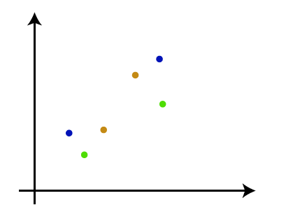

**Step 2:** Take two closest data points or clusters and merge them to form one cluster. So, there will now be N-1 clusters.

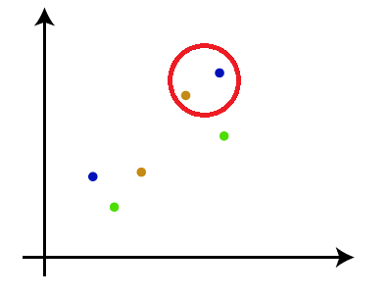

**Step 3:** Again, take the two closest clusters and merge them together to form one cluster. There will be N-2 clusters.

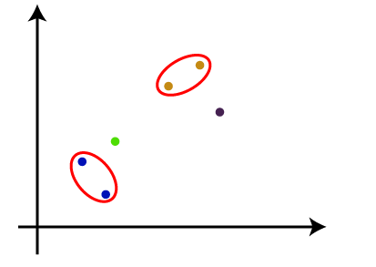

**Step 4:** Repeat Step 3 until only one cluster left. So, we will get the following clusters. Consider the below images:

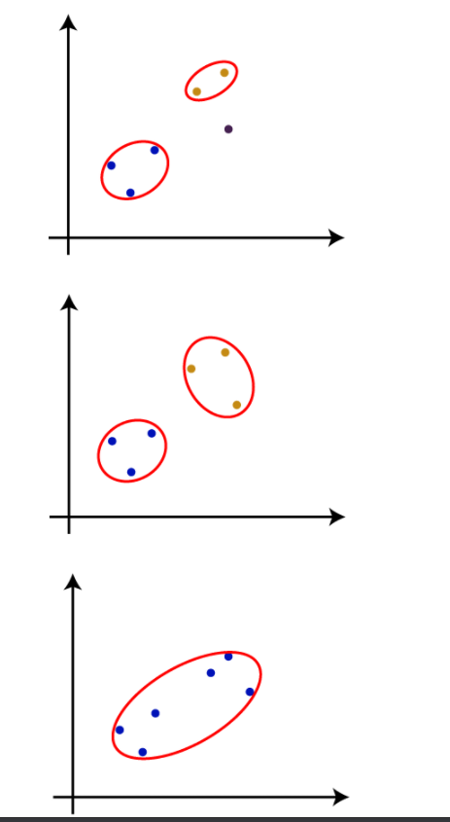

**Step 5:** Once all the clusters are combined into one big cluster, develop the dendrogram to divide the clusters as per the problem.

**Reference:**

[**https://www.javatpoint.com/hierarchical-clustering-in-machine-learning**](https://www.javatpoint.com/hierarchical-clustering-in-machine-learning)

**Understanding Machine Learning From Theory to Algorithms – Cambridge University Press**

**https://www.geeksforgeeks.org/ml-hierarchical-clustering-agglomerative-and-divisive-clustering/**